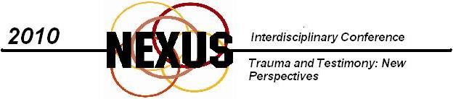
University of Tennessee-Knoxville
Thursday, March 18-Saturday, March 20, 2010
Web Address: http://web.utk.edu/~nexus
Plenary Speakers: Cathy Caruth (Emory University) and Julia Levine
This conference seeks to explore the relationship between trauma and testimony, and in particular the therapeutic possibilities and potential problems that testimony entails. Testimony is the term used in trauma studies to talk about the process of articulating or expressing one’s trauma for an “Other” as a crucial step in recovering from the trauma.
As an interdisciplinary conference, we welcome submissions from relevant fields and disciplines. Abstracts (250-300 words) are invited on a broad range of topics including, but not limited to, the following:
- Representations of shared traumatic events (the Holocaust, 9/11, Hurricane Katrina, etc.)
- Ethical issues of truth versus “creative license” in representation
- The role of both the speaker and the listener
- The limits of representation
- Whose history is it, anyway? First-person testimony vs. bearing witness from the “outside”
- Testimony and Therapy—the therapeutic value of telling one’s story
- Testimony and Justice—the Truth and Reconciliation Commission experiment
- Bearing witness using contemporary media (the Shoah Foundation, blogs, etc.)
- Testimony and Action—Telling as a Catalyst for Change
- Collective Suffering and Collective Guilt—the historical and ethical limits of trauma and testimony
- Interdisciplinary Studies—Trauma as experienced through the prisms of race, gender, sexuality, class, and other categories of identification
- Trauma and the Law—Issues of victims’ rights
- Papers written on literary and/or artistic representations of trauma
- Creative submissions
- The future of trauma studies
Individual papers or panel proposals will be considered. As this is an interdisciplinary conference, please feel free to submit proposals which speak to your academic interests, even if they do not fit neatly into the categories listed above.
Please submit abstracts to Dennis McGlothin (dmcgloth@utk.edu) or Teresa Lopez (tlopez@utk.edu) by January 15, 2010.

